Warning! Promoter Wanted in Witmart!

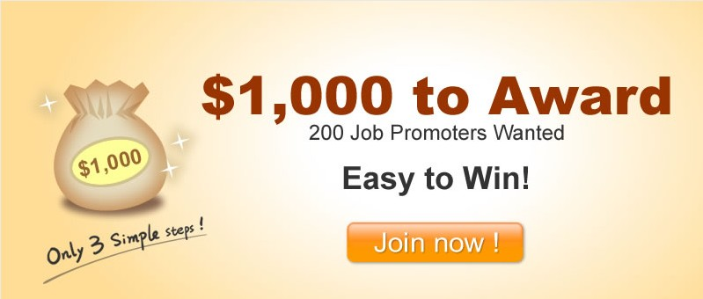

Thousands of opportunities have been offered from Witmart.com for anyone who is willing to join us and make money. One of the latest functions which have just been brought out was called the ‘Promoter Invitation Function’. You get paid via simply invited new users to get registered with Witmart. The best part about this feature is, it will only take you few minutes, but you earn form it!!!!!

Step one------ Get Registered and Start Now!
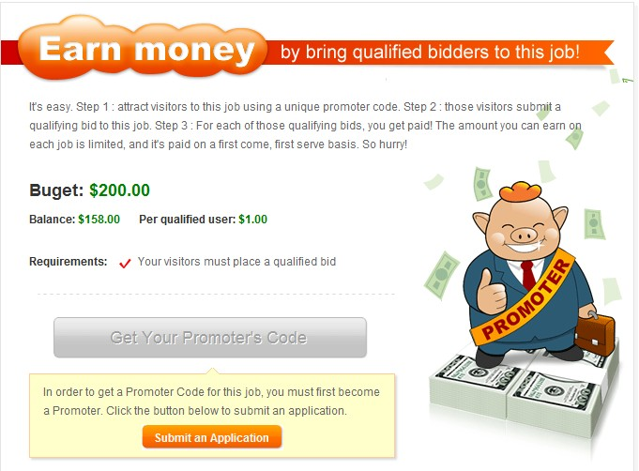

First of all, you should apply online and become a valid licensed user of Witmart in order to become a Promoter. You are supposed to provide valid and trustful information while you fill in the application form. Soon after the application was submitted, you will be contacted by phone to verify you ID if your answers were approved by Witmart. Once the ID is qualified, you can feel free to apply any job which has enabled the Promoter Function.

Step two-----Become a promoter and start your promotion!!
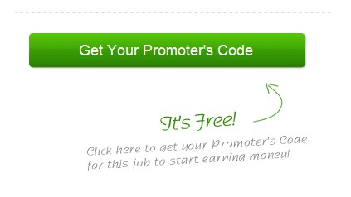
Once you successfully applied for a Witmart ID, it is the time for you to become a promoter now. A link will be provided when you click on the ‘get your promotion code’ button when you. This link will be used to track the traffic that you bring in and bring you to the job page. It will also measure whether or not the visitors or bids are qualified.

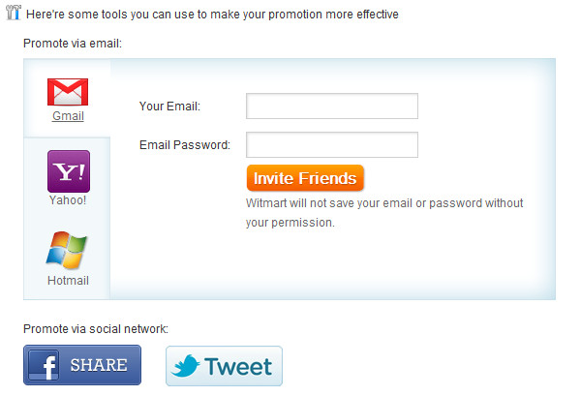

It is highly recommended that the best way to invite people to register and bid is to make use of social media sites like Facebook, Twitter, micro-blogs, blogs, etc. Please make sure to include your links when you make a post to one of these sites; otherwise it won’t be counted! Then you can feel free to email/twitter/Facebook the link to your friends, and get them join us together! Once the friend you invited has been approved and bid, it is the time for you to get your money.
Important Hint!
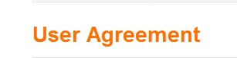
（link: http://www.witmart.com/help/terms.html）

Witmart is a trustful and reliable platform. Therefore, it is vital for you keep in mind that the importance of not violating the User Agreement Policy when it comes to the Promoter function. Your Promoter’s license could be revoked if you violate the policy. You will take the full responsibility for any unreliable actions taken on your part. So before you start, please do read the User Agreement Policy carefully and tick ‘agree’ when you finish read it.

Come on!
Just move your fingers and click on your mouse!
Invite your friends and you can make the best!



