My experience with Jison case
The JS-IP4S-005 for the iPhone 4S
Ordering
Ordering the slim fit case for the iPhone 4S is an easy and uncomplicated system once you have created your Jison Case account. I liked the way you can choose the colors of which there are 10 available.
Being a lively and fun loving person I decided on a rose pink to match my personality.
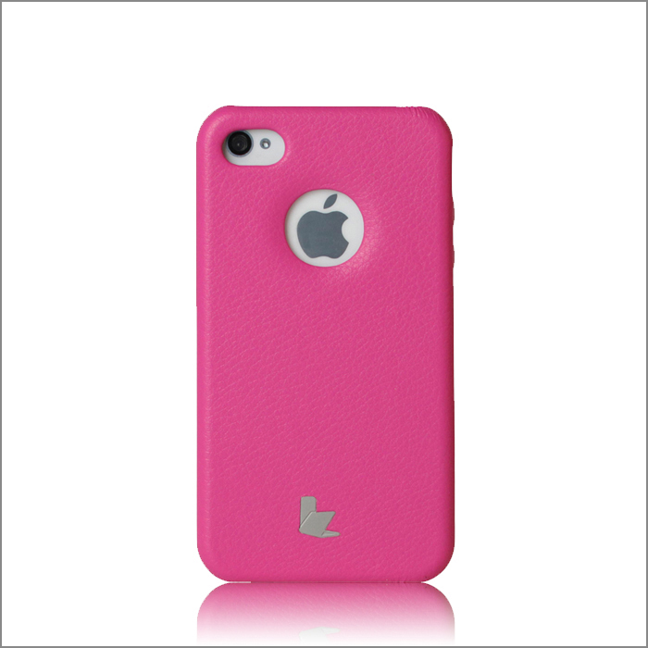

Delivery Time from ordering
I placed my order on a Tuesday Morning along with a payment authorized on PayPal. Once the payment had been confirmed I was informed by email of the expected date of delivery along with a tracking number for DHL which was my preferred choice of carrier. The package arrived right on time as Jison case had informed me and I was very impressed that the goods were delivered so quickly when you consider that they had been shipped over half way round the world. What makes this company more efficient is that they ship directly from their home base location, rather than forwarding to another transport hub for onward dispatch.
The packaging
The parcel was very well packaged with a good clear view of the delivery paperwork that was sealed against the weather in a clear plastic bag. The package itself was well sealed and the corners had been additionally taped for added strength.
Opening the packaging
When the carton was opened my slim fir case was nicely packaged in a thin white micro fiber sleeve that covered the entire case box, Taking the box out of the sleeve I was immediately aware of how light this case is, which is a good thing because it meant there would not be a lot of additional weight added to the iPhone. The packaging itself is strong but basic. No fancy printing or plastic inserts to hold the case into place, the case has a small string handle on the top edge which can be used to hang it on shop display racks but also is useful for slipping the inner cardboard case holder out of the outer sleeve.
First impressions
When the case was taken out of its cardboard holder I was impressed by the feel of the slim fit case, it felt well made and strong but more than anything extremely light. The edging and cut outs are all extremely well done and there is no stitching or excess glue to be seen. Jison Case is different in that they do not use stitching for their corners preferring instead to glue the edges and cover them all neatly with their micro board inlay.
The fit
The iPhone 4S was easy to put in the case it literally just slots into place and is held firmly. There are two cut outs on the back that allow the Apple logo and camera to remain easy to see. All of the other ports are shielded partially but remain easily accessible, with some soft indentations on one side that lets you control the volume just below the cut out for the camera button.

Ease of use
The slim fit case is easy to use and keep clean, all of the ports are easy to plug into with headphones, charging and computer hook up a breeze.
Final thoughts
In conclusion the JS-IP4S-005 Slim fit case is a good all round protector for the iPhone 4S, it is easy to use and will keep your phone looking good for all of its lifetime. I fully recommend this product from Jison case and will have no hesitation in ordering from them again in the future.

